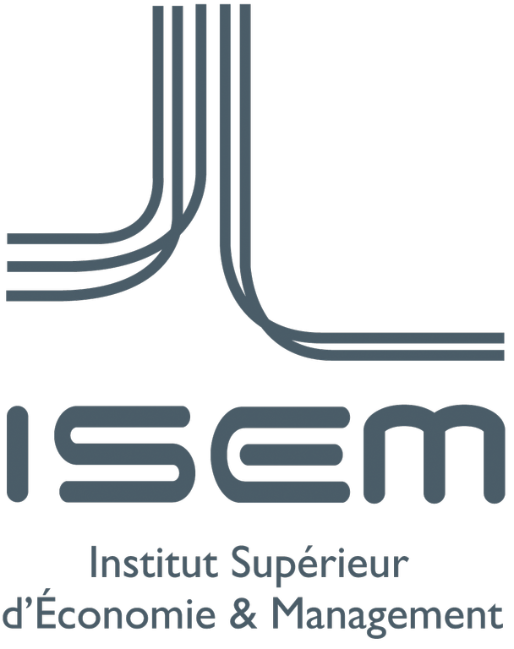
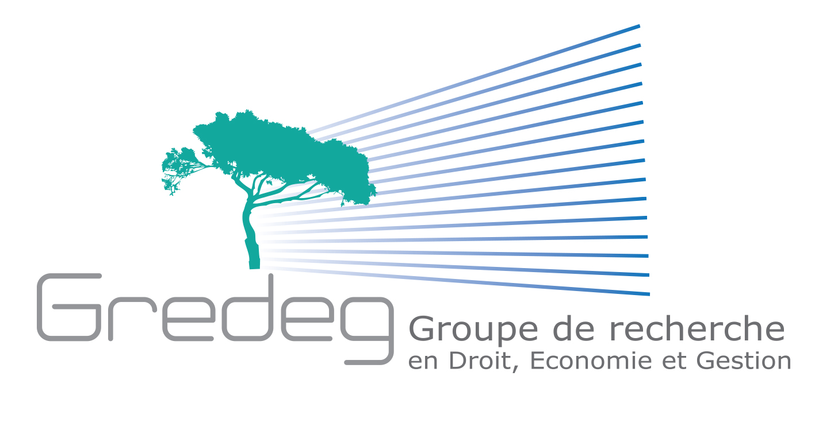
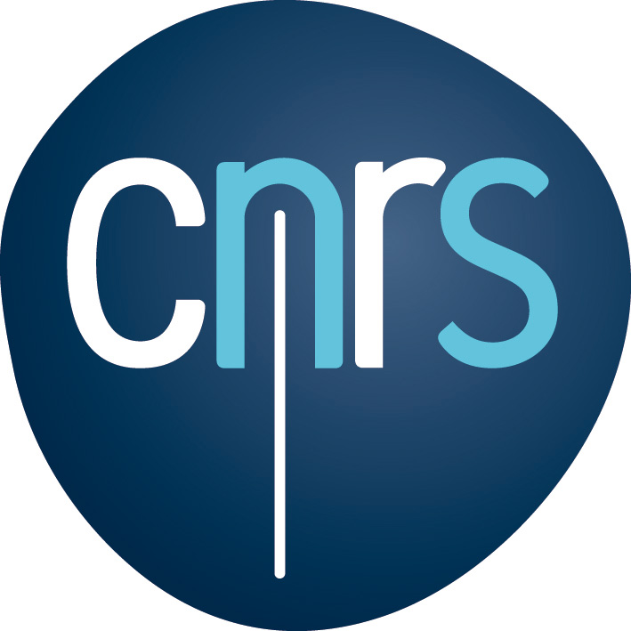
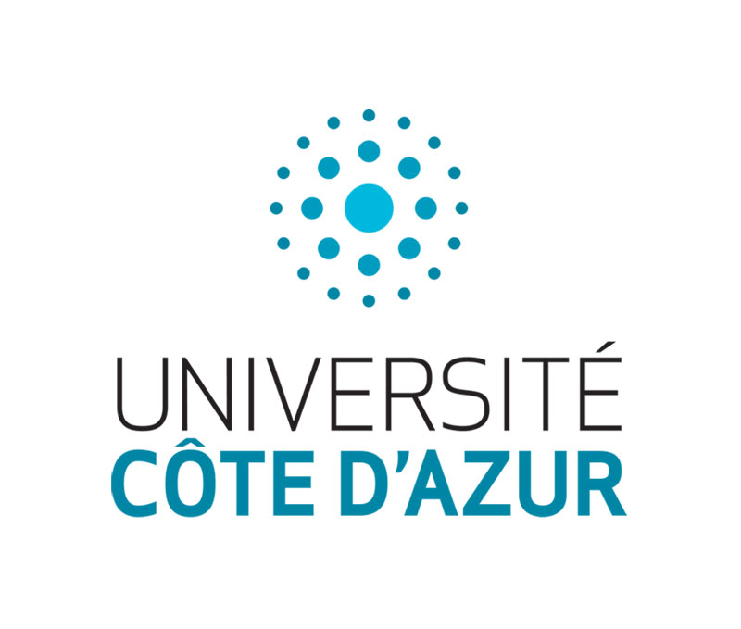

Université Côte d’Azur Mobility Allocation for Outstanding International Students
Applicants for a Master Degree in “Innovation, Digitalization and Territories”

September 2018 -June 2019

@ Institut Supérieur d’Economie et de Management (ISEM)
The EUR "Digital Systems for Humans" provides financial and non-financial support to high-achieving and committed students from all over the world

Master program scholarship content

Brief description - The UCA Mobility Allocation for International Students enables graduate students and young professionals from abroad to study and conduct research at Université Côte d’Azur. It is awarded to international students with interests in economics and management of innovation and digital changes.

The Scholarship covers a year (two semesters) of a master’s degree in “Innovation, Digitalization and Territories” and includes a 4 to 6 months’ internship (research stay) at the GREDEG (Groupe de Recherche en Droit, Economie et Gestion) Research Centre.
The research project is part of a larger pluridisciplinary program conducted in collaboration with the LEAT (Research Centre in Microelectronics – Laboratoire d’Electronique, Antennes et Télécommunications – UMR CNRS 7248), entitled “Smart IoT for Mobility”. The main research question is concerned with the social uses of smart contracts and digital trust issues in these new forms of contracts implemented in connected objects. The method used in the project will be primarily experimental and conducted in the experimental economics lab (Laboratoire d’Economie Expérimentale de Nice – LEEN).

Host institutions - The successful candidate will be part of the Université Côte d’Azur that is seen as a catalyst that will transform its territory through a different mode of thought, of entrepreneurship, and of research and development.
In particular, the scholarship is awarded by the pluridisciplinary academy of excellence “Networks, Information and Digital Society” which aims at improving comprehension of the transformation brought about by the digitalization of society, especially the impact of technological innovation and the role of physical artifacts in this transformation.
The Master Degree in “Innovation, Digitalization and territories” is delivered by the Institut d’Economie et de Management de Nice which gathers economics and management programs at both undergraduate and graduate levels. The internship will take place at GREDEG (UMR CNRS 7321).

Fields of study - The successful candidate will be invited to work on the social acceptance of smart contracts in the uses of connected objects and mobility services. In particular, the notion of digital trust will be assessed in experimental studies. Experiments will be conducted in the experimental platform at the LEEN (Laboratoire d’Economie Expérimentale de Nice).

Scholarship value/ duration - The scholarship amounts to 5.500 € granted in two separate payments of 2.750 € per semester. Scholarship is awarded without consideration of personal or parent income. It cannot be cumulated with other scholarships if their total amount is higher than 500 € / month.

Eligibility requirements

The Grant will be awarded to outstanding international undergraduate (3rd year) or postgraduate students. Candidates with French nationality will not be considered. Applicants should demonstrate quality of their academic curriculum and records; their creativity potential and scientific independence.
Familiarity with data analysis and programming would be appreciated.
A score of B2 at the French proficiency test and a good knowledge of English are expected.

At the end of his/ her 1st year Master degree at ISEM, the successful candidate should then aim to apply to a 2nd year Master program at ISEM. A candidate aiming at applying for a Ph.D. programme at GREDEG will be considered more seriously.

Application material and deadlines

- Detailed CV
- Cover letter including motivation
- Academic records (from A levels/ Baccalaureate grades to current records)
- One reference letter is highly recommended.

The Call is launched on May 14th, 2018.
The Deadline is June 15th, 2018.
Skype interviews will be organized between June 15th and June 30th, 2018.
Results will be announced by July 6th, 2018.

For questions, contact: lise.arena@unice.fr or agnes.festre@unice.fr

